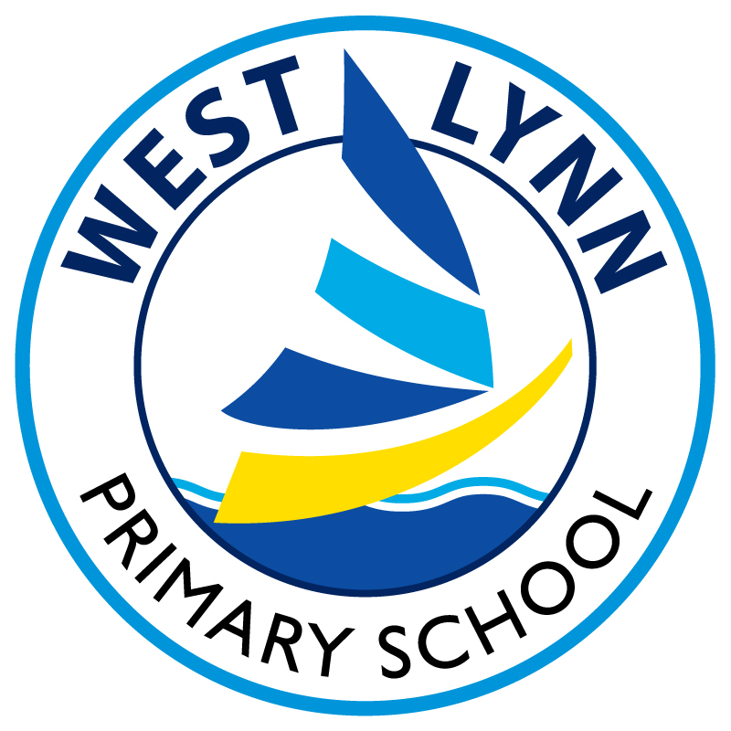

Clenchwarton, Walpole Cross Keys & West Lynn
Primary Schools

Use of digital images (photography and video)
Parent/Carers Agreement

To comply with the Data Protection Act 2018 and GDPR, we need your permission before we can photograph or make recordings of your daughter/ son.

We follow the following rules for any external use of digital images:

If the pupil name is visible, we avoid using their photograph.
If their photograph is used, we avoid using names or identifying individual children.

Where showcasing examples of pupils work we only use their first names, rather than their full names.

We will only use pupil’s first names in credits.
Only images of pupils in suitable dress are used.

Examples of how digital photography and video may be used include:

- Your child being photographed (by the classroom teacher, teaching assistant or another child) as part of a learning activity; e.g. photographing children at work and then sharing the pictures through a projector/on screen in the classroom allowing the children to see their work and make improvements.

- Your child’s image for presentation purposes around the schools; e.g. in school wall displays and electronic presentations to capture images around the schools or in the local area as part of a project, lesson or assemblies.

- Your child’s image being used in a presentation about the schools and its work in order to share its good practice and celebrate its achievements, e.g. Our schools’ websites or the media.

Child’s Name……………………………………….

Note: If we, or you, actually wanted your child’s image linked to their name we would contact you separately for permission, e.g. if your child won a national competition and wanted to be named in local or government literature.

Use of digital images - photography and video: I also agree to the schools using photographs of my child or including them in video material, as indicated below. I have read and understood this document and I understand that images will only be used to support learning activities or in publicity that reasonably promotes the work of the schools, and for no other purpose.

Please tick to provide consent as appropriate:

[ ] In School eg Display boards, groups
[ ] On School website
[ ] In the School’s Newsletter (this also goes on the website)
[ ] In the School Prospectus
[ ] In Promotion for the School eg Artsmark
[ ] In the Local Press (No surnames included) please note these can go press
social media pages
[ ] On School Social Media eg Facebook, Twitter

Parent / carer signature: _______________________________ Date: ___/___/___


